***Chemistry***

**18: Representative Metals, Metalloids, and Nonmetals**

**18.7: Occurrence, Preparation, and Properties of Nitrogen**

59. Write the Lewis structures for each of the following:

(a) NH2–

(b) N2F4

(c) 

(d) NF3

(e) 

Solution

(a) NH2–:

;

(b) N2F4:

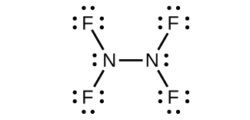;

(c):

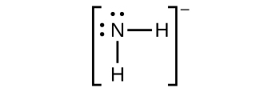;

(d) NF3:

;

(e):



61. Explain how ammonia can function both as a Brønsted base and as a Lewis base.

Solution

Ammonia acts as a Brønsted base because it readily accepts protons and as a Lewis base in that it has an electron pair to donate.

Brønsted base: 

Lewis base: 

63. For each of the following, draw the Lewis structure, predict the ONO bond angle, and give the hybridization of the nitrogen. You may wish to review the chapters on chemical bonding and advanced theories of covalent bonding for relevant examples.

(a) NO2

(b) 

(c) 

Solution

(a) NO2:



Nitrogen is *sp*2 hybridized. The molecule has a bent geometry with an ONO bond angle of approximately 120°.

(b):

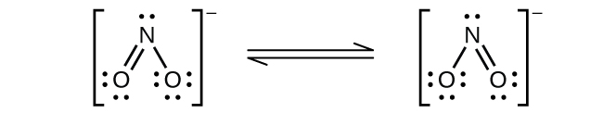

Nitrogen is *sp*2 hybridized. The molecule has a bent geometry with an ONO bond angle slightly less than 120°.

(c):



Nitrogen is *sp* hybridized. The molecule has a linear geometry with an ONO bond angle of 180°.

65. Although PF5 and AsF5 are stable, nitrogen does not form NF5 molecules. Explain this difference among members of the same group.

Solution

Nitrogen cannot form a NF5 molecule because it does not have *d* orbitals to bond with the additional two fluorine atoms.

This resource file is copyright 2015, Rice University. All Rights Reserved.